RACHEL RENEE
THEATRE
Music Man Marian(Us)/Ensemble Light Opera Works/Rudy Hogenmiller
Side by Side by Sondheim Woman1&2, Narrator(Us) Light Opera Works/Rudy Hogenmiller
Hunchback of Notre Dame * Esmerelda(Us)/Ensemble Bailiwick Repertory Theatre/David Zak
Oklahoma Laurey (Us)/Ensemble Light Opera Works/Rudy Hogenmiller
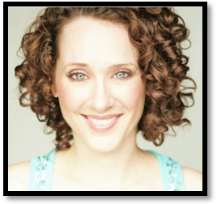
Saga Ruby Luxury Cruise Ship (UK) Female Lead Singer Sixth Star Productions
Saga Rose (UK) Female Lead Singer Morag Productions/Morag Veljkovic
Asuka Luxury Cruise Line (Japan) Female Lead Singer Morag Productions/Morag Veljkovic
The Mikado Yum-Yum Union Theatre/David Furumoto
Orpheus in the Underworld Eurydice Music Hall/William Farlow
Hansel & Gretel Gretel Music Hall/William Farlow
She Stoops to Conquer Constance Neville Hemsley Theatre/Robert Spencer
A Little Night Music Anne Egerman Union Theatre/Paul Dennhardt
The Boyfriend Hortense Hemsley Theatre/Cynthia White
Jesus Christ Superstar Mary Magdalene Middleton Players/Andy Abrams
Assassins Squeaky Fromme Strollers Theatre/J. Patrick
Frankenstein Elizabeth Frankenstein Verona Productions/J. Patrick
Funny Thing Happened… Philia Madison Theatre Guild/J. Patrick
Hair : Brown Billy Liz CTM-Madison/Nancy Thurow
Eyes : Green/Blue The Fantastiks Louisa Racine Youth Players/Maxwell Mount
Height : 5’5” Have a Nice Day! Ronda Racine Theater Guild/Norman McPhee
Weight : 118 Comedy Sportz Team Player Madison Troupe/Bryan Judkins
Voice : Soprano/Belter/Mix Fame! Serena Racine Youth Players/Maxwell Mount
Wizard of Oz Dorothy Racine Theater Guild/Norman McPhee
*Jeff award Winner Best Musical 2008
FILM

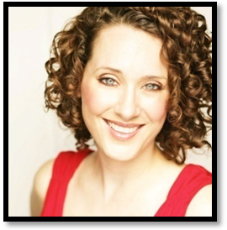
Nighthawk Allison/Lead Eric Brown Productions
Public Enemies Extra Universal Pictures (Michael Mann)
An Impression of Prospection Wandering Woman/Lead Aaron Catalano Productions
The Captain and Me Wench#3/Featured Warehouse District Productions
Crossman isn't in Today Clerk #3/Featured Tudor Twins Prints
Edmond Featured Extra Red Hen Productions (Stuart Gordon)
Shady Oaks Dawn/Lead Shady Oaks Productions
Morning Light Virginia/Lead Jordan Allot Productions
I Love Paris Jessica/Lead A Touchdown Production
TRAINING

B.A. & M.M. Degrees in Music Performance; Voice/Opera and Theater; Acting Specialist at UW Madison
Voice: Neil Semer, Randy Breuscher, Richard Boldrey, Mimmi Fulmer, Robert Swensen
Drama: Patricia Boyette, Karen Ryker, Norma Saldivar, John Staniunas
www.rachelrenee.com Acting for Film: Stuart Gordon & Stuart K. Robinson
Dance: University of Wisconsin Madison Ballroom Dance Association, Joel Hall & Lou Conte (Tap, Ballet, Jazz, Modern)

SPECIAL SKILLS

Voice Coach, Conversational Spanish, Dance and Choreography, Limited Piano, Driver’s License, Can Sing in German, Italian, French and Latin; Dialects, Sports, Ballroom Dancing, Downhill Skiing, Tennis, Horseback Riding, Firearms, Hiking, Aerobics, Running, Fencing, Fly Fishing, CPR, Kabuki Theater, Hip Hop, Energy!

